|  |  |
| --- | --- |
| Name | Abdul Hannan Ibrahim |
| Registration # | 23-NTU-CS-1002 |
| Assignment# | 1 |
| Course Name | Embedded IOT Systems |
| Section | BSCS-5th-A |
| Department | Computer Science |
| Submit To | Mr. Nasir Mehmood |
| Date | 23-09-2025 |

**Circuit:**

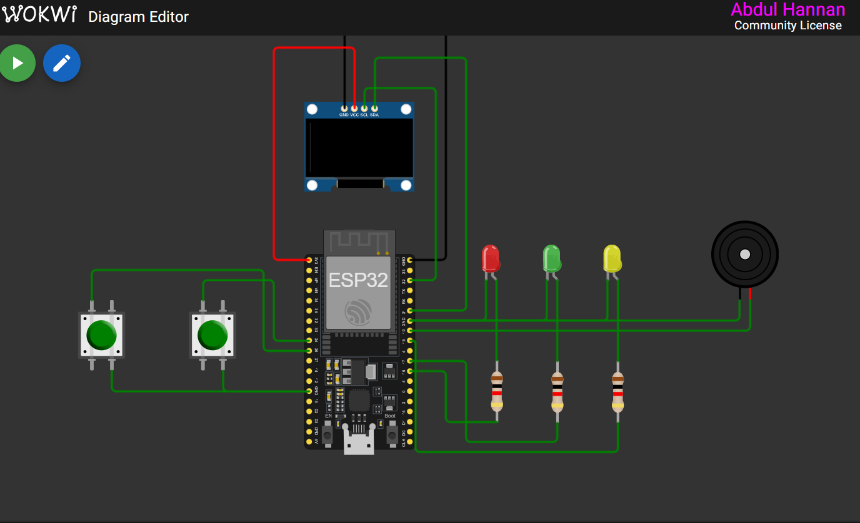

**Task 1:**

**Code:**

#include <Wire.h>

#include <Adafruit_GFX.h>

#include <Adafruit_SSD1306.h>

#define SCREEN_WIDTH 128

#define SCREEN_HEIGHT 64

#define OLED_RESET    -1

Adafruit_SSD1306 display(SCREEN_WIDTH, SCREEN_HEIGHT, &Wire, OLED_RESET);

// LEDs

#define LED_YELLOW 18

#define LED_GREEN 17

#define LED_RED 16

// Buttons

#define BTN_CYCLE 25

#define BTN_RESET 26

// PWM fade

int fadeValue = 0;

int fadeDirection = 1;

// Button debounce

const unsigned long DEBOUNCE_MS = 30;

int lastReadingCycle = HIGH, stableCycle = HIGH, lastStableCycle = HIGH;

unsigned long lastDebounceCycle = 0;

int lastReadingReset = HIGH, stableReset = HIGH, lastStableReset = HIGH;

unsigned long lastDebounceReset = 0;

// LED mode: 0=OFF, 1=ALT BLINK, 2=ALL ON, 3=PWM FADE

int ledMode = 0;

bool blinkState = false;

unsigned long lastBlinkTime = 0;

const unsigned long BLINK_INTERVAL = 500;

const unsigned long FADE_INTERVAL = 10;

unsigned long lastFadeTime = 0;

void setup() {

  pinMode(BTN_CYCLE, INPUT_PULLUP);

  pinMode(BTN_RESET, INPUT_PULLUP);

  pinMode(LED_YELLOW, OUTPUT);

  pinMode(LED_GREEN, OUTPUT);

  pinMode(LED_RED, OUTPUT);

  // OLED init

  if (!display.begin(SSD1306_SWITCHCAPVCC, 0x3C)) { for(;;); }

  display.clearDisplay();

  display.setTextSize(2);

  display.setTextColor(SSD1306_WHITE);

  // Initial LED off

  analogWrite(LED_YELLOW, 0);

  analogWrite(LED_GREEN, 0);

  analogWrite(LED_RED, 0);

}

void loop() {

  unsigned long currentMillis = millis();

  // -------- Handle Cycle Button --------

  int readingCycle = digitalRead(BTN_CYCLE);

  if (readingCycle != lastReadingCycle) lastDebounceCycle = currentMillis;

  if (currentMillis - lastDebounceCycle >= DEBOUNCE_MS) {

    if (stableCycle != readingCycle && lastStableCycle == HIGH && readingCycle == LOW) {

      ledMode++;

      if (ledMode > 3) ledMode = 0;

      fadeValue = 0; fadeDirection = 1; blinkState = false;

      lastBlinkTime = currentMillis; lastFadeTime = currentMillis;

    }

    stableCycle = readingCycle;

  }

  lastReadingCycle = readingCycle;

  lastStableCycle = stableCycle;

  // -------- Handle Reset Button --------

  int readingReset = digitalRead(BTN_RESET);

  if (readingReset != lastReadingReset) lastDebounceReset = currentMillis;

  if (currentMillis - lastDebounceReset >= DEBOUNCE_MS) {

    if (stableReset != readingReset && lastStableReset == HIGH && readingReset == LOW) {

      ledMode = 0;

      analogWrite(LED_YELLOW, 0);

      analogWrite(LED_GREEN, 0);

      analogWrite(LED_RED, 0);

      fadeValue = 0; fadeDirection = 1; blinkState = false;

      lastBlinkTime = currentMillis; lastFadeTime = currentMillis;

    }

    stableReset = readingReset;

  }

  lastReadingReset = readingReset;

  lastStableReset = stableReset;

  // -------- LED modes --------

  switch(ledMode){

    case 0: // All OFF

      analogWrite(LED_YELLOW, 0);

      analogWrite(LED_GREEN, 0);

      analogWrite(LED_RED, 0);

      break;

    case 1: // Alternate blink

      if (currentMillis - lastBlinkTime >= BLINK_INTERVAL) {

        blinkState = !blinkState;

        lastBlinkTime = currentMillis;

      }

      analogWrite(LED_YELLOW, blinkState ? 255 : 0);

      analogWrite(LED_GREEN, blinkState ? 0 : 255);

      analogWrite(LED_RED, blinkState ? 255 : 0);

      break;

    case 2: // All ON

      analogWrite(LED_YELLOW, 255);

      analogWrite(LED_GREEN, 255);

      analogWrite(LED_RED, 255);

      break;

    case 3: // PWM fade

      if (currentMillis - lastFadeTime >= FADE_INTERVAL) {

        fadeValue += fadeDirection * 5;

        if (fadeValue >= 255) { fadeValue = 255; fadeDirection = -1; }

        if (fadeValue <= 0)   { fadeValue = 0; fadeDirection = 1; }

        analogWrite(LED_YELLOW, fadeValue);

        analogWrite(LED_GREEN, fadeValue);

        analogWrite(LED_RED, fadeValue);

        lastFadeTime = currentMillis;

      }

      break;

  }

  // -------- OLED display --------

  display.clearDisplay();

  display.setCursor(0,20);

  switch(ledMode){

    case 0: display.println("ALL OFF"); break;

    case 1: display.println("BLINK"); break;

    case 2: display.println("ALL ON"); break;

    case 3: display.println("PWM FADE"); break;

  }

  display.display();

}

**Task 2:**

Code:

#include <Wire.h>

#include <Adafruit_GFX.h>

#include <Adafruit_SSD1306.h>

#define SCREEN_WIDTH 128

#define SCREEN_HEIGHT 64

#define OLED_RESET    -1

Adafruit_SSD1306 display(SCREEN_WIDTH, SCREEN_HEIGHT, &Wire, OLED_RESET);

#define BUTTON_PIN 25

#define LED_PIN    18

#define BUZZER_PIN 15

const unsigned long LONG_PRESS_MS = 1500;

const unsigned long DEBOUNCE_MS = 50;

int lastButtonState = HIGH;

int stableState = HIGH;

unsigned long lastDebounce = 0;

unsigned long pressStart = 0;

void setup() {

  pinMode(BUTTON_PIN, INPUT_PULLUP);

  pinMode(LED_PIN, OUTPUT);

  pinMode(BUZZER_PIN, OUTPUT);

  if (!display.begin(SSD1306_SWITCHCAPVCC, 0x3C)) for(;;);

  display.clearDisplay();

  display.setTextSize(2);

  display.setTextColor(SSD1306_WHITE);

  digitalWrite(LED_PIN, LOW);

  digitalWrite(BUZZER_PIN, LOW);

}

void loop() {

  unsigned long currentMillis = millis();

  int reading = digitalRead(BUTTON_PIN);

  // Debounce

  if (reading != lastButtonState) lastDebounce = currentMillis;

  if (currentMillis - lastDebounce >= DEBOUNCE_MS) {

    if (stableState != reading) {

      stableState = reading;

      if (reading == LOW) pressStart = currentMillis;  // button pressed

      else {  // button released

        unsigned long pressDuration = currentMillis - pressStart;

        display.clearDisplay();

        display.setCursor(0,20);

        if (pressDuration < LONG_PRESS_MS) {

          // Short press → toggle LED

          digitalWrite(LED_PIN, !digitalRead(LED_PIN));

          display.println("Short Press");

        } else {

          // Long press → buzzer

          tone(BUZZER_PIN, 1000, 500);

          display.println("Long Press");

        }

        display.display();

      }

    }

  }

  lastButtonState = reading;

}